Experiment 3:

**Create a s3 Bucket versioning**

**Step-1.Create S3 bucket and give name as roll number.**

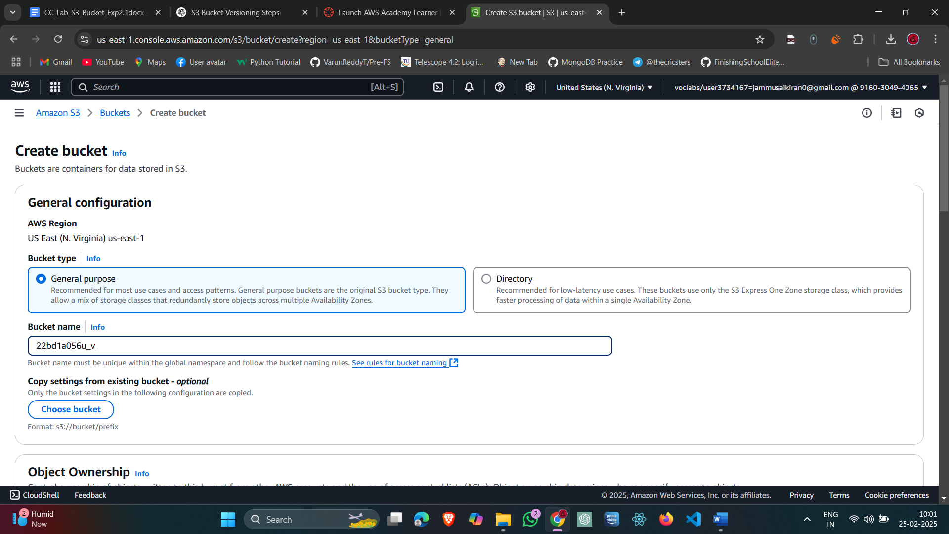

**Fig-3.1: Creating S3 bucket**

**Step:2.Uncheck All the public access and Check the Acknowledge box:**

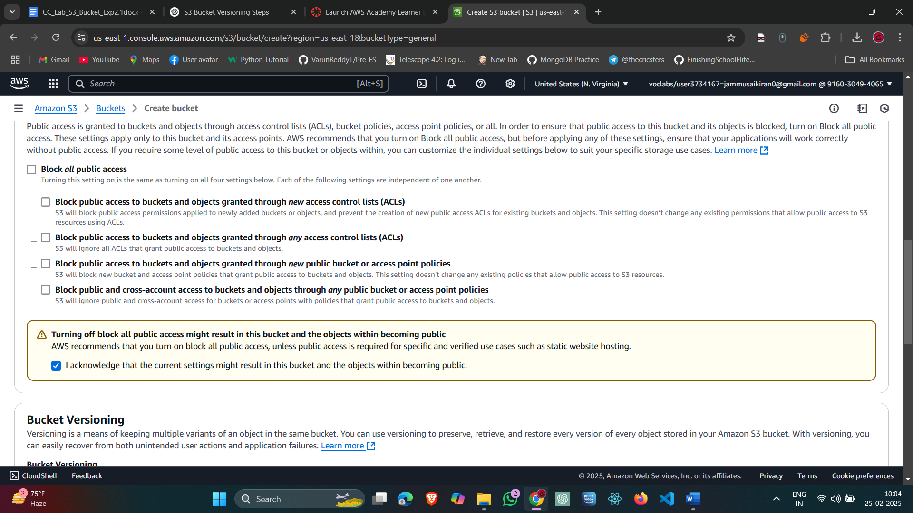

**Fig-3.2: Setting up bucket configurations**

**Step-3.Successfully Bucket created:**

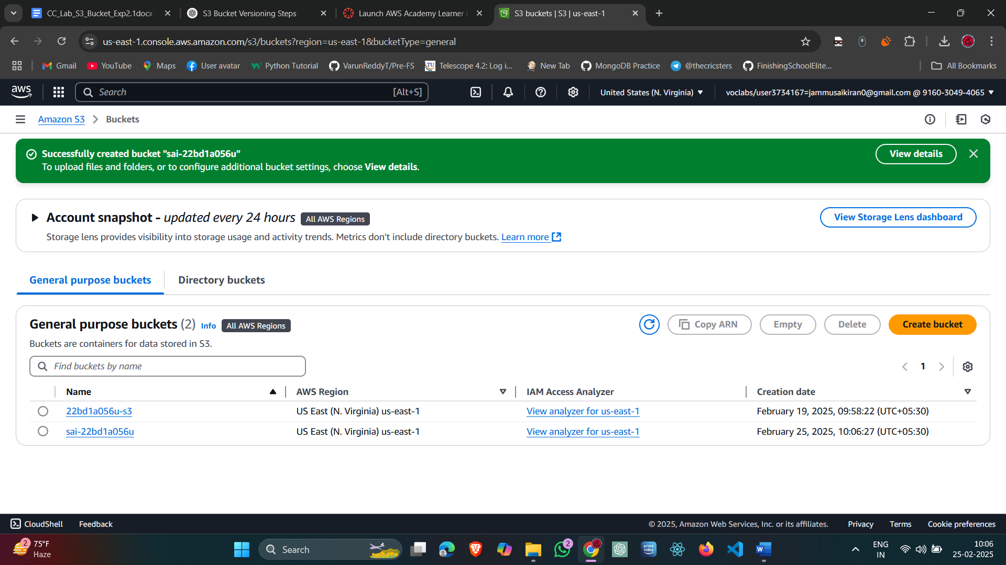

Fig-3.3: bucket created

Step 4.Upload the Object that is image:

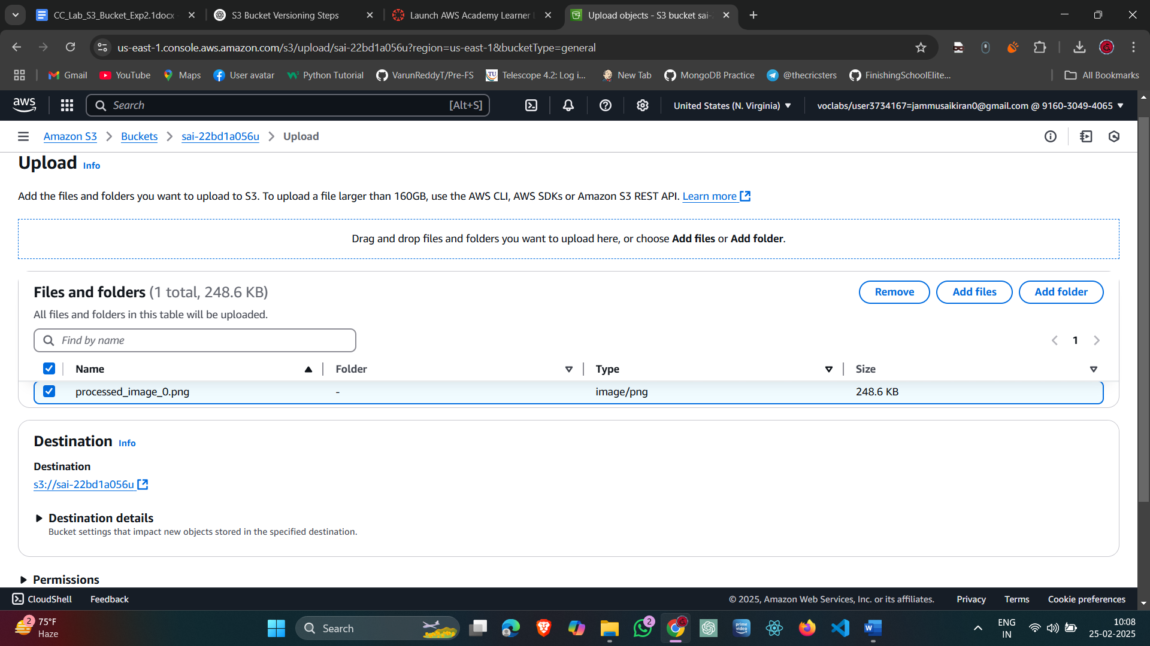

Fig-3.4:Upload the image.

Step-5. Successfully Uploaded the image:

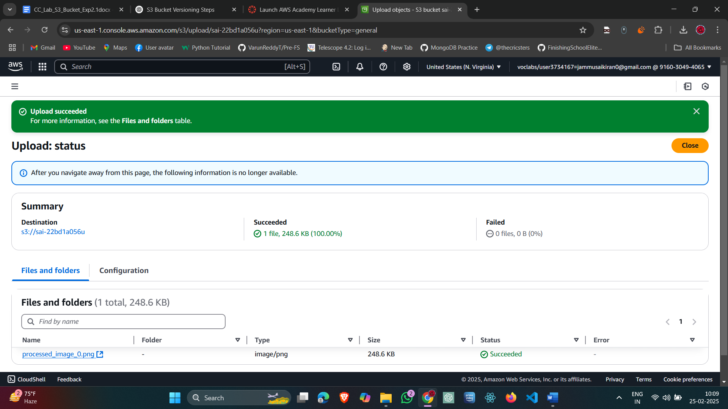

Fig-3.5: Image uploaded

Step-6:Edit access control list:

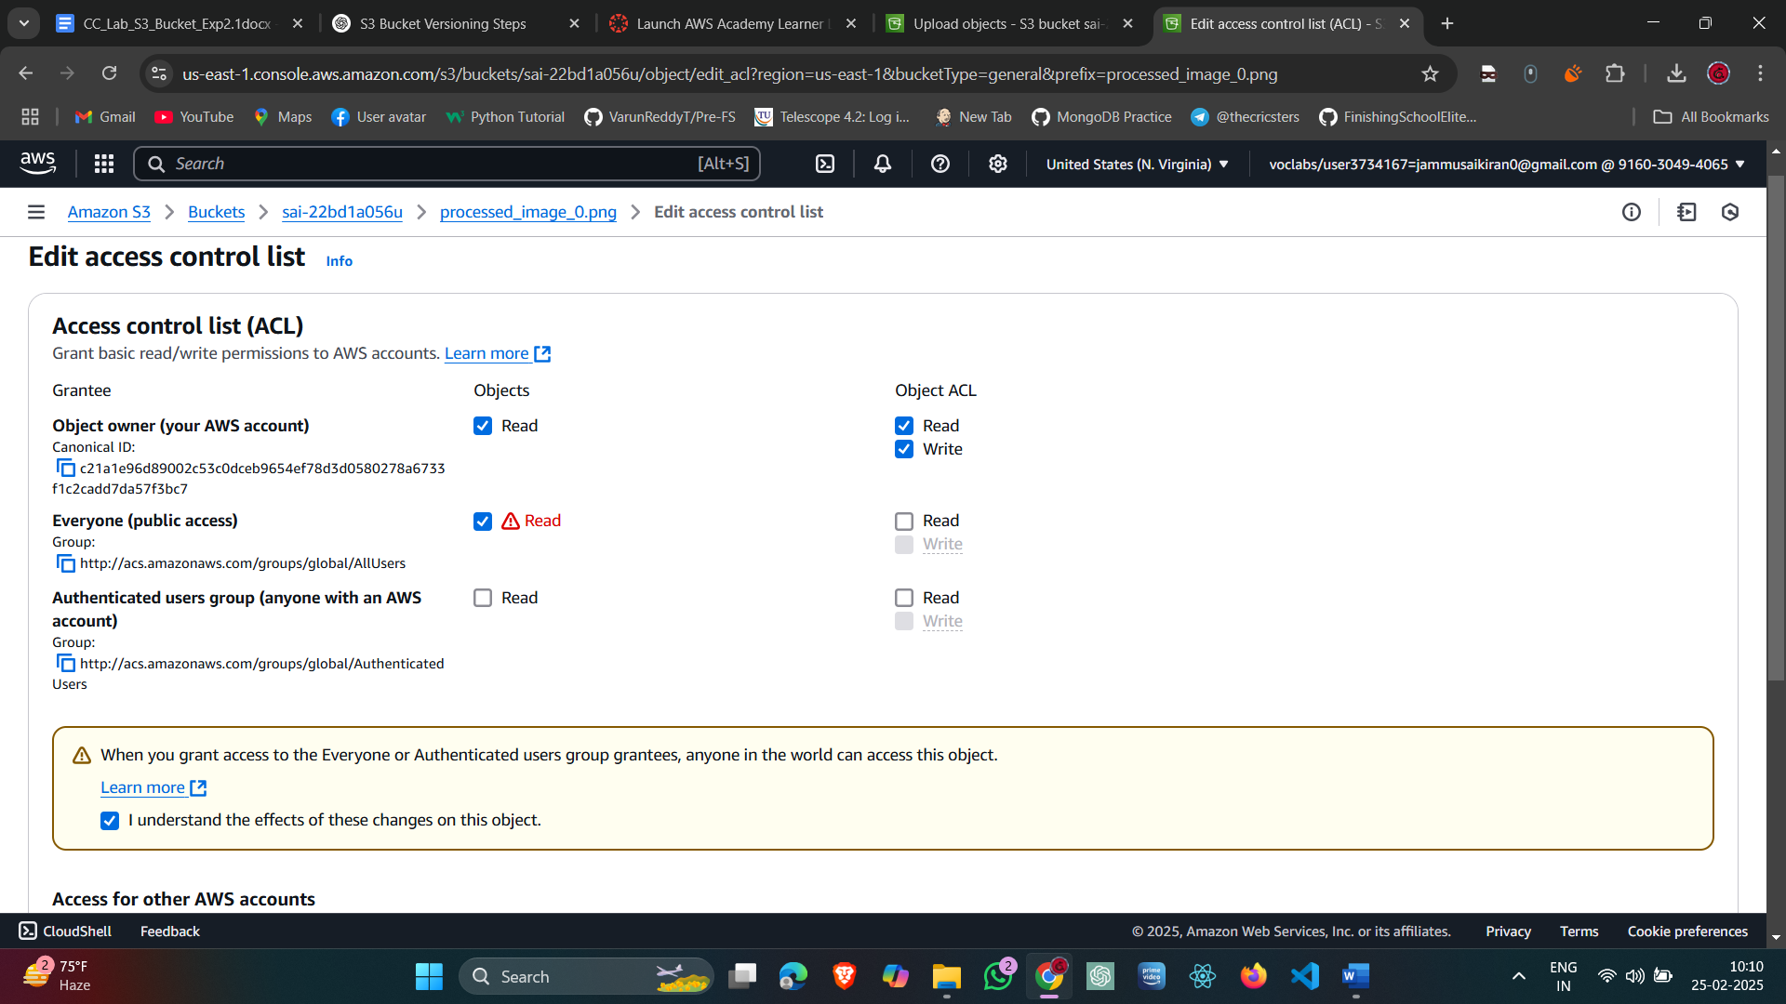

Fig-3.6: Editing control list.

Step-7:Saved and Successfully Edited Access Control list:

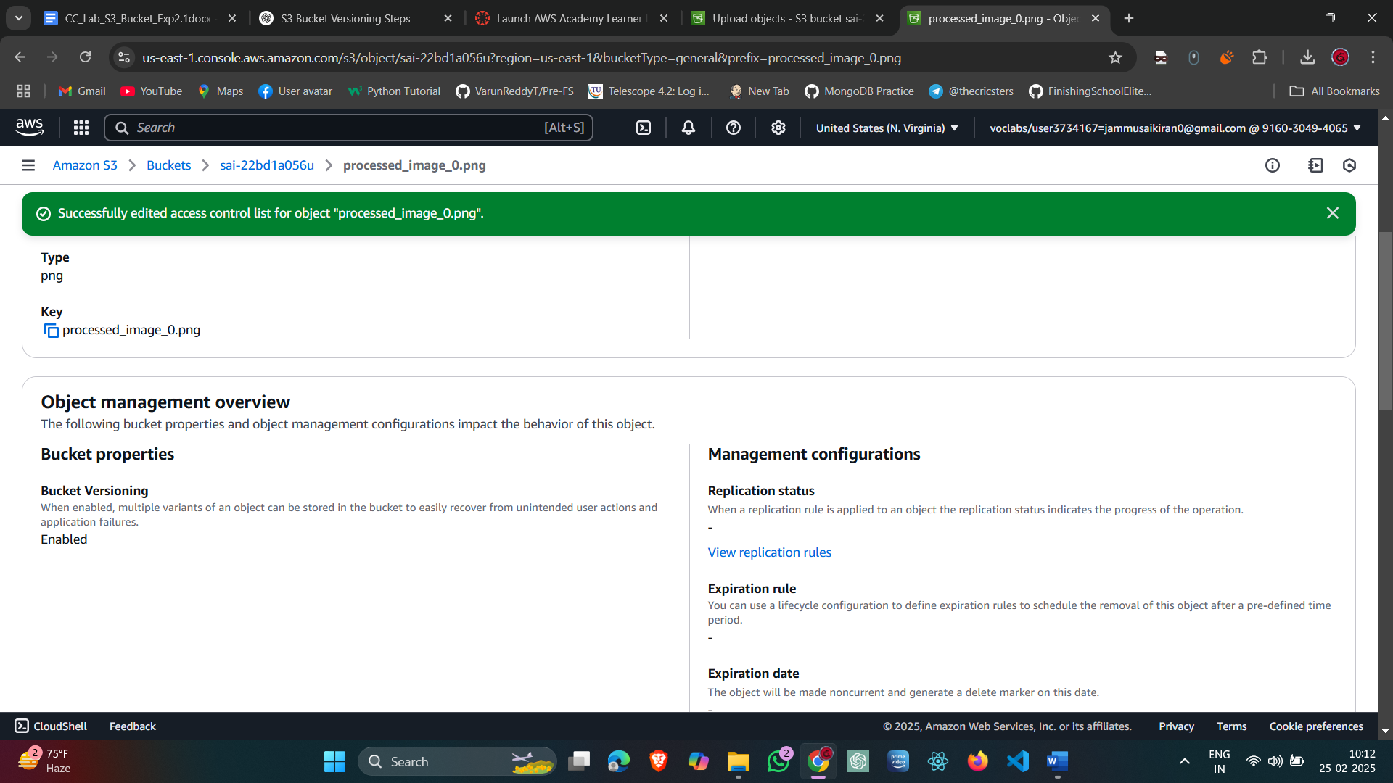

Fig-3.7: Successfully saved.

Step-8:Click on Object URL :



Fig-3.8: Output in the browser.

Step-9:Upload Second image with same name as previous image:

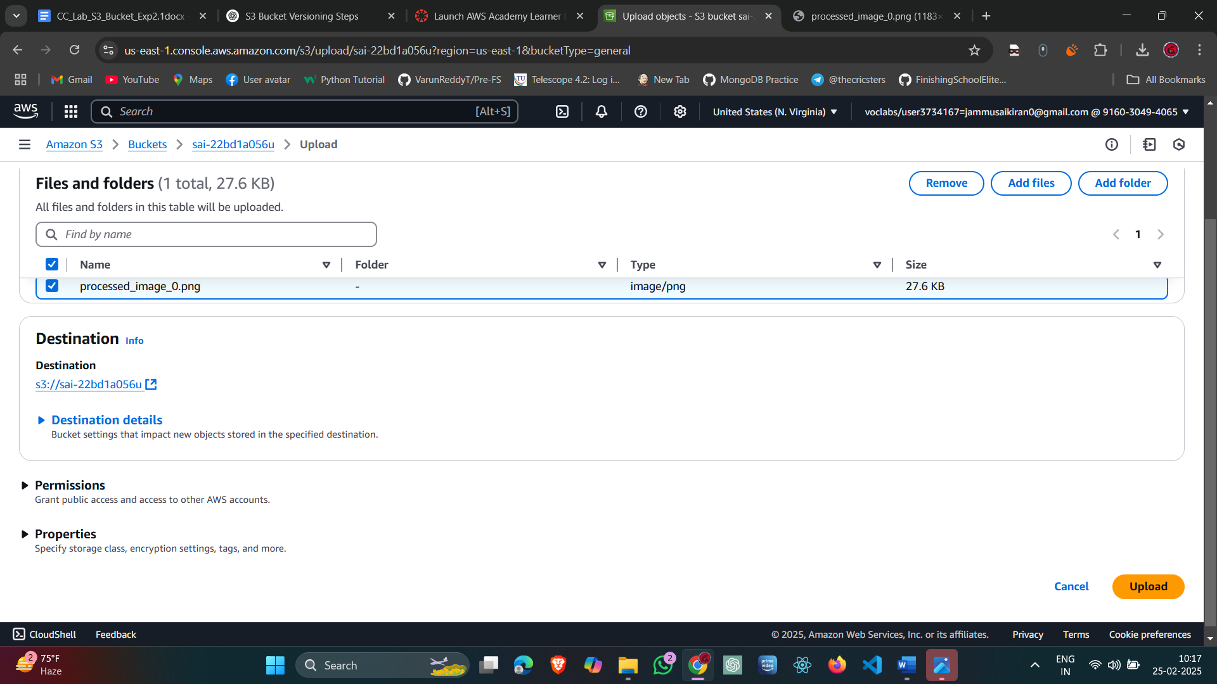

Fig-3.9: upload second image.

Step-10:Successfully Uploaded:

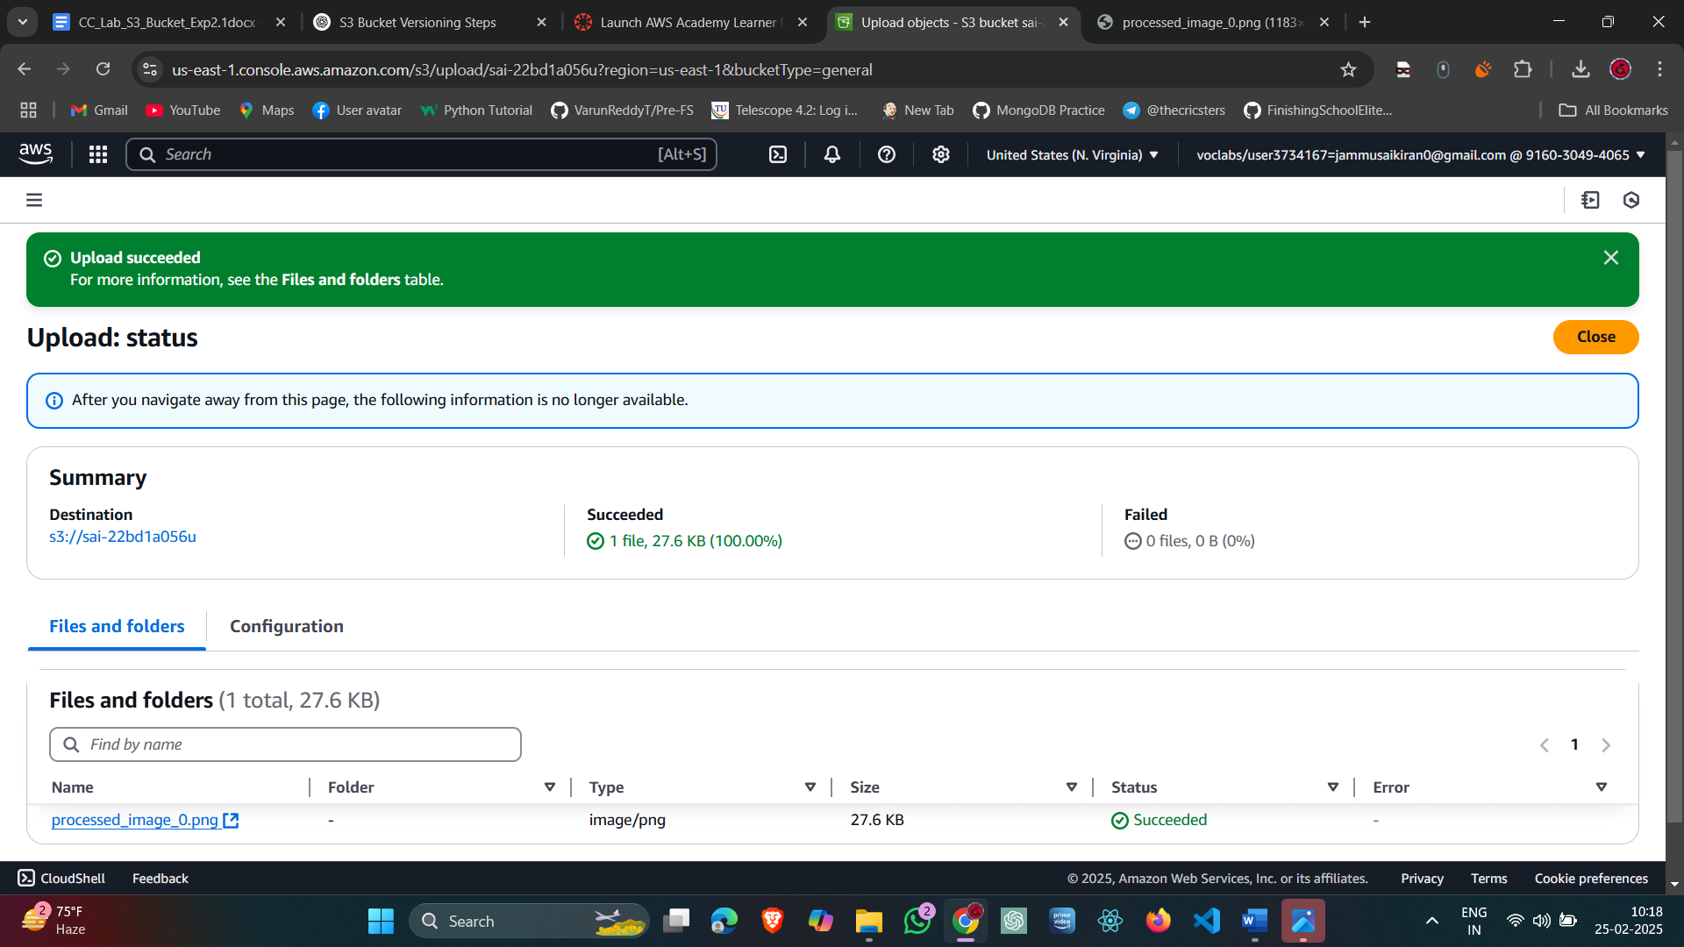

Fig-3.10: Another image uploaded into the bucket.

Step-11: Change the Permissions of the Image:

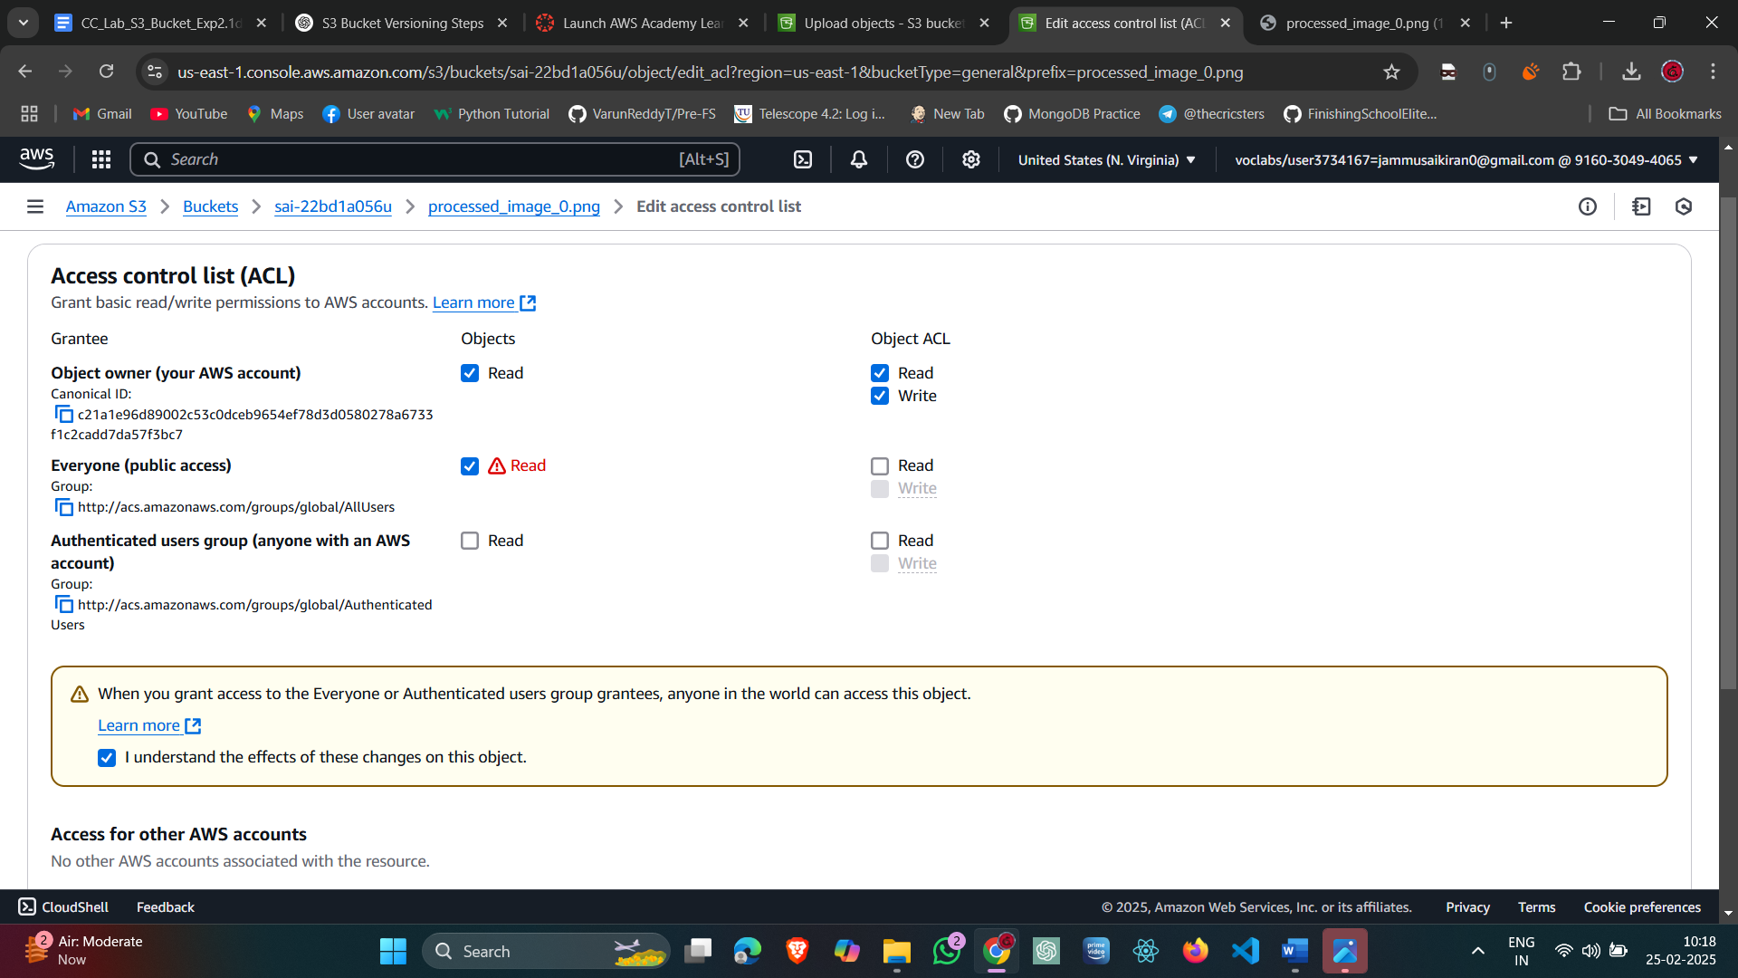

Fig-3.11: Edit second image controls

Step 12: Successfully Edited and Click on the Object URL:

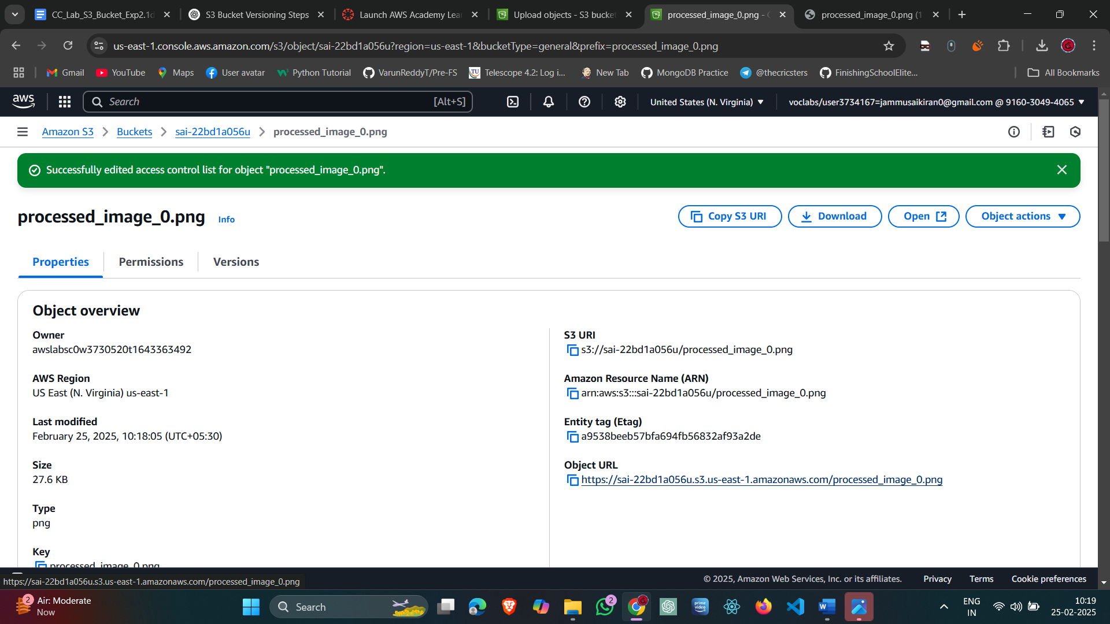

Fig-3.12: Click on the url.

Step 13: The image is displayed:

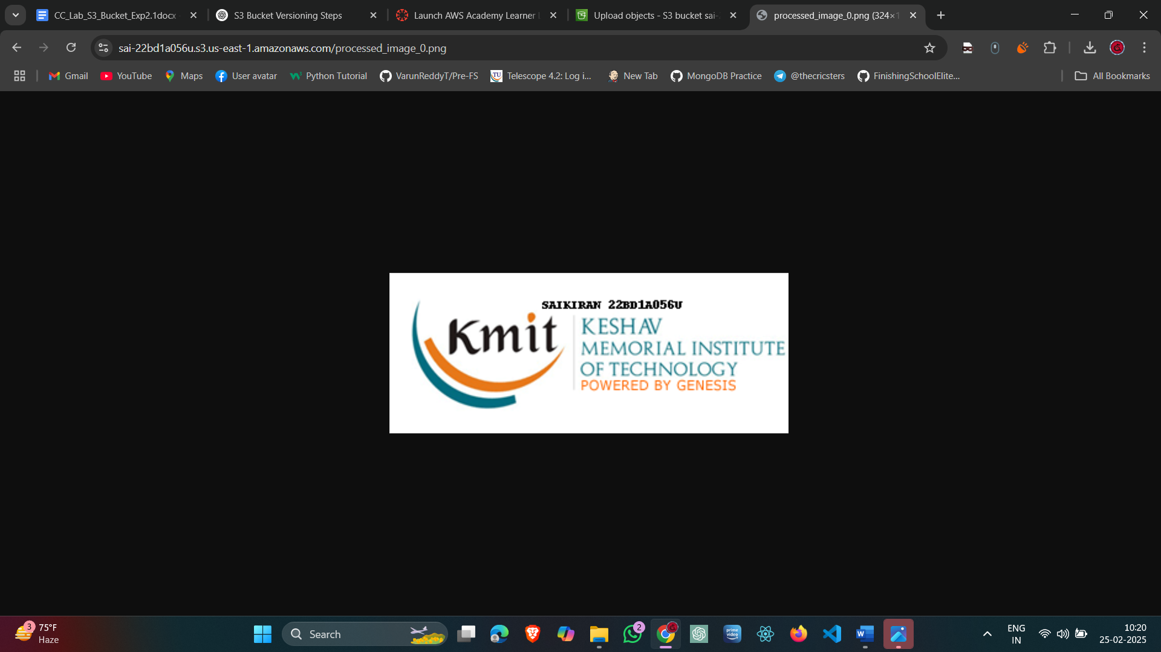

Fig-3.13: second image is displayed.

Step 14: Delete the image:

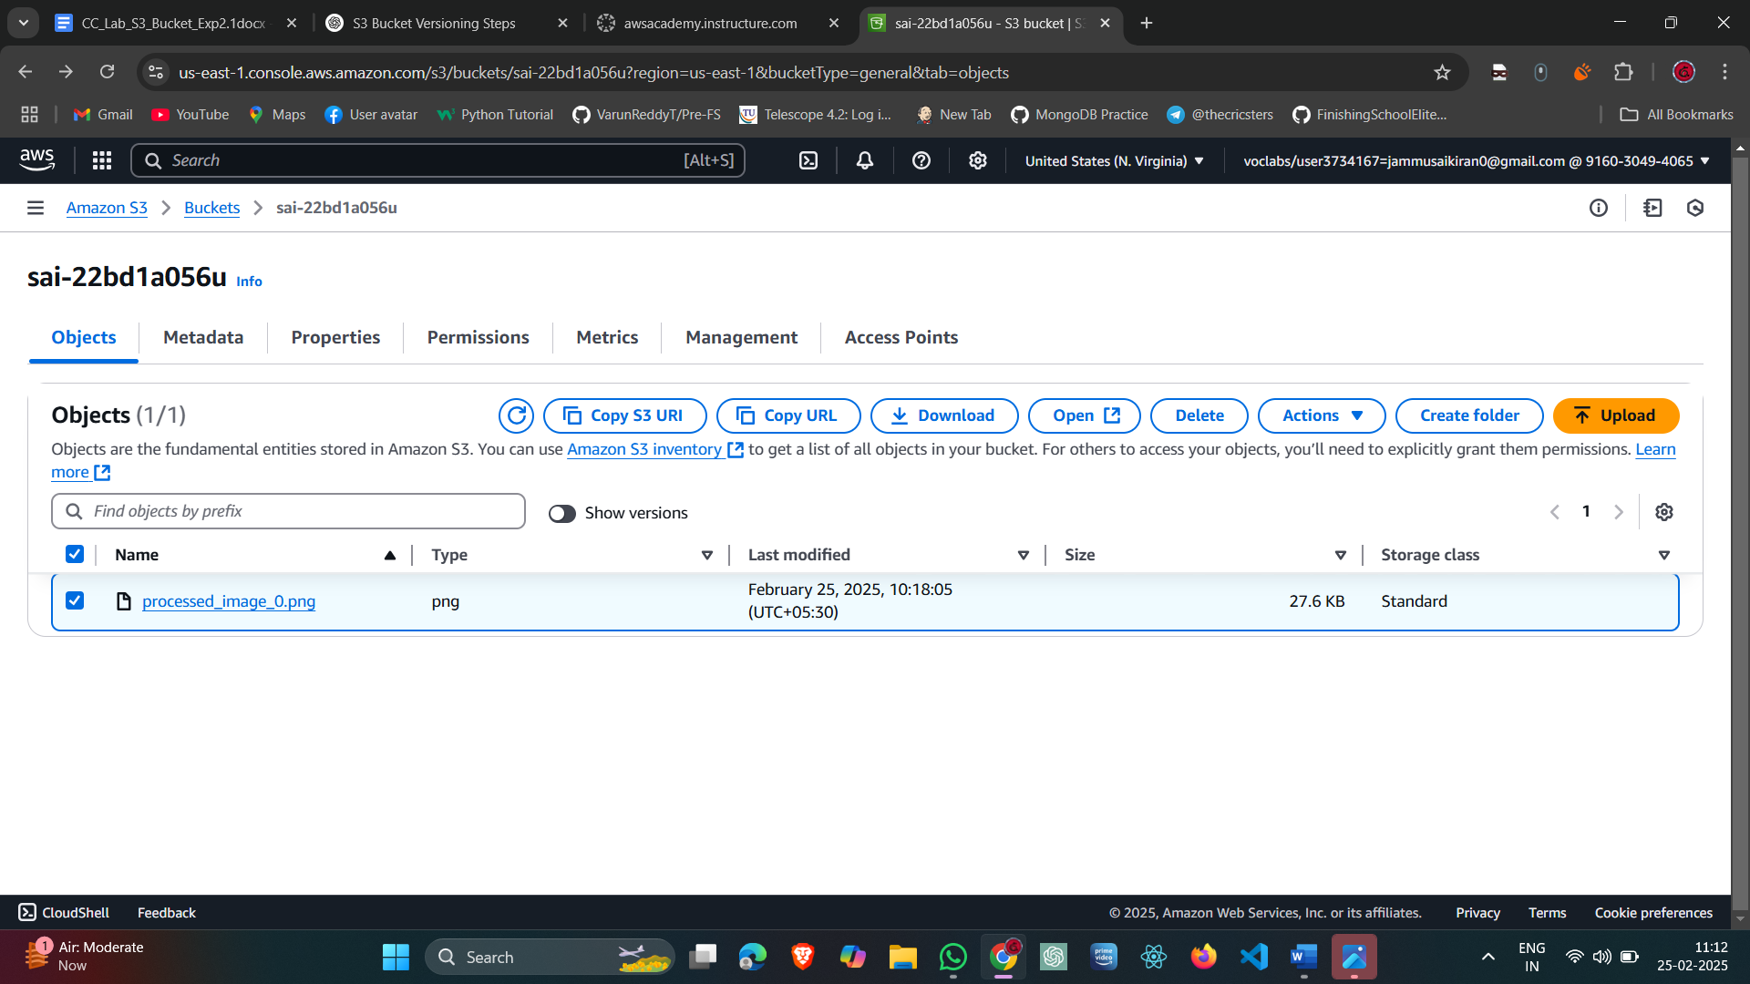

Fig-3.14: Deleting the image

Step 15: Confirm deleting the image:

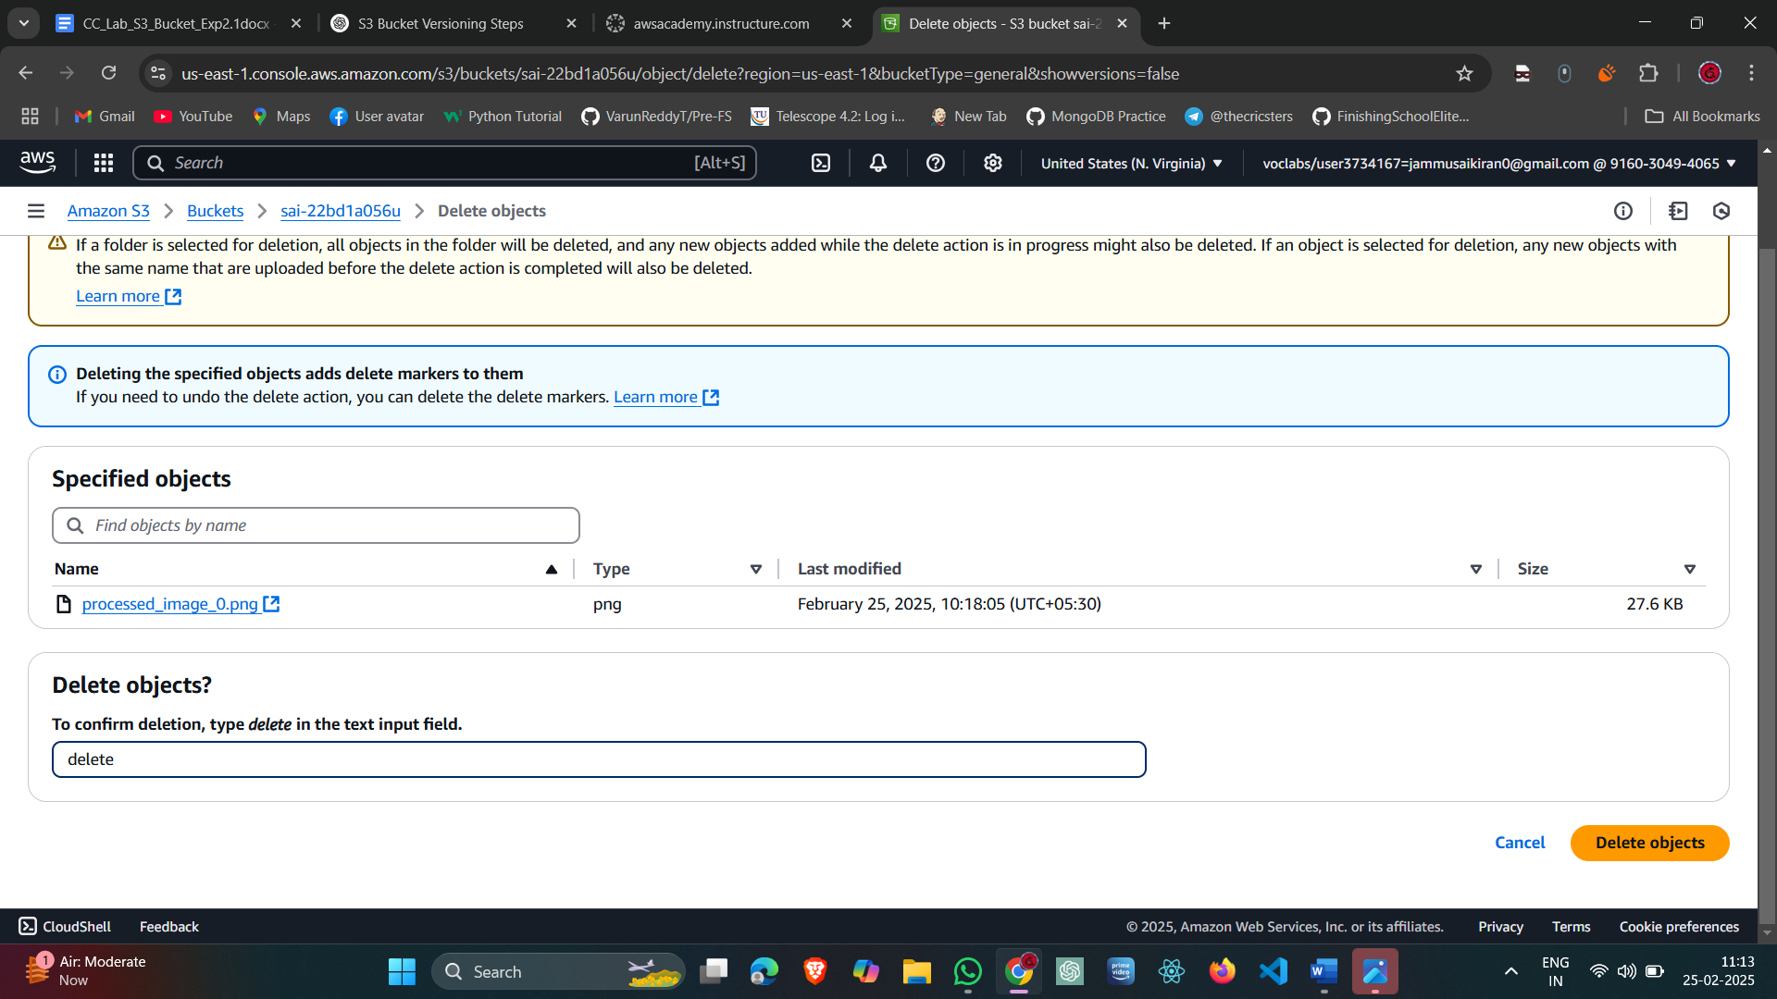

Fig-3.15: confirm delete

Step 16: Deleting delete marker of a object.

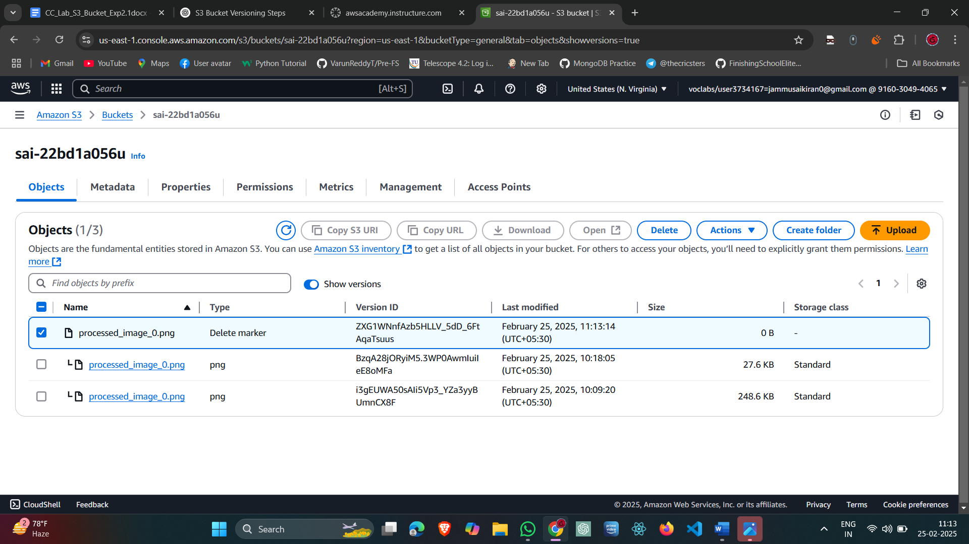

Fig-3.16: Deleting the delete marker

Step 17: Delete permanently

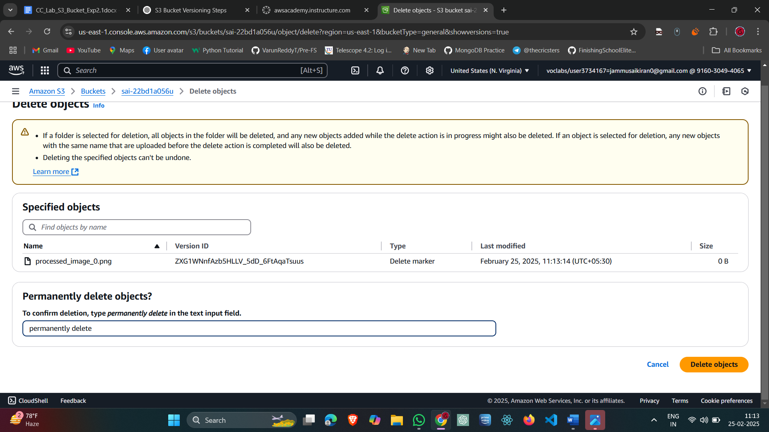

Fig-3.17: Delete permanently

Step 18: Image Successfully recovered:

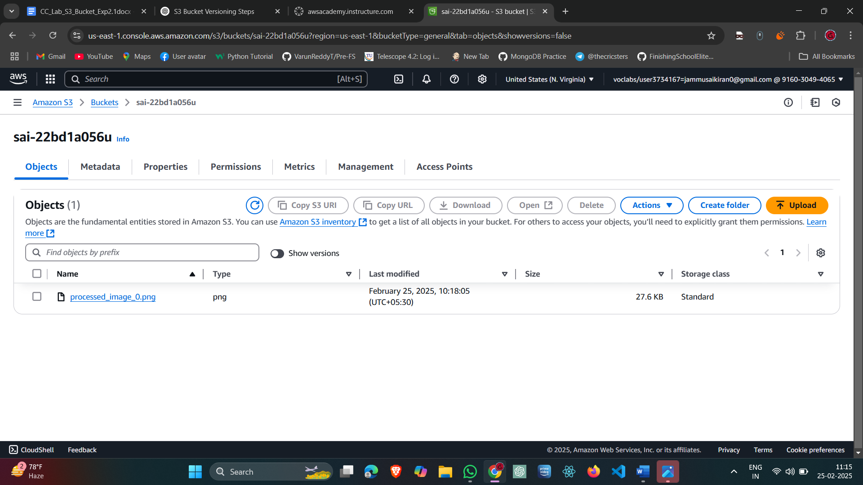

Fig-3.18: Image recovered.